**To What Extent is Time Travel Possible?**

After many years of confusion regarding the fact that the speed of light appeared to be invariant under transformations between reference frames, many theoretical physicists, including the better known Lorentz and Einstein, found that the transformations of position and time were not as simple as first thought. It turned out that time and space distort each other, and when the speeds of objects are close to the speed of light, the seemingly separate dimensions of space and time merge into one continuum of ‘spacetime’. Once Einstein had created his Theories of Relativity, our understanding of time was totally turned on its head, and suddenly, a whole new area of physics appeared to open up – the idea of time travel, an idea which had been thought to be ridiculous, was now one to be seriously considered.

**Special Relativity**

**Time Travel into the Future**

Once Einstein’s Theory of Special Relativity was published, physicists realised that time travel into the future was not just a possibility, but something that happened all of the time. It was found that whenever an object moving with speed *v* relative to an observer, the moving object’s internal clocks slows down by the Lorentz factor, *γ*,[2] which is defined as:

where *c* is the speed of light. Whenever *c* is written in the future, it will mean the speed of light, equivalent to exactly 299,792,458 metres per second. For example, if the object’s speed according to an observer appears to be one millimetre per second slower than *c*, its Lorentz factor is about 400,000. This means that for every 400,000 seconds that pass for the observer, only one second appears to pass for the moving object in the observer’s frame of reference. Someone travelling at this speed, theoretically, would be able to travel to the Andromeda Galaxy in just over six years, as opposed to the two and a half million years it’s calculated to take if Special Relativity isn’t taken into account. The fact that this is a form of time travel becomes clear when one imagines that once the traveller reaches Andromeda, he returns to home at the same speed relative to the reference frame of the observer back on Earth. When the traveller returns to Earth, he may find it to be a very different planet, as his journey only seemed to take a little more than twelve years, while in the reference frame of the Earth, the journey took five million years to complete. Effectively, the traveller moved about five million years into the Earth’s future – an extreme case of time travel into the future. The closer the object’s speed is to *c*, the larger it’s Lorentz factor is, and the rate at which the object is able to move into the future of the observer increases. This phenomena was proved to happen by flying atomic clocks around the world and comparing them to clocks back on the ground after the trip.[3]

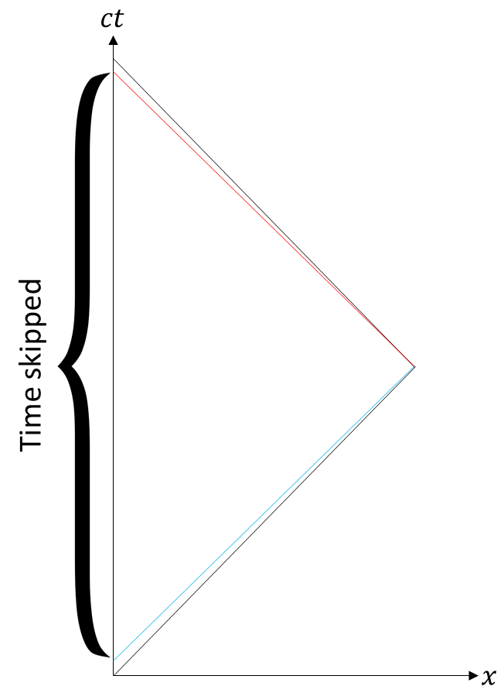The diagram to the left is a spacetime diagram,[4] used to pictorially represent relativistic effects, with the y-axis being time multiplied by *c*, and the x-axis being the *x* coordinate position (the *y* and *z* coordinates are not considered). The reason that the time axis is multiplied by *c* is so that the paths of light are at 45° to the axes. The black diagonal lines are the path of the traveller, and the blue and red lines are the lines on which events happen at the same time for the traveller on the way to and from Andromeda respectively. Due to the acceleration at the end of the first half of the journey, the traveller seems to jump forward into the future of the observer.

*The differing Lorentz transformations of the Earth’s point in time from the traveller’s reference frame causes it to appear to jump into the future*

*Point where the traveller turns around*

*Velocity is close to -c*

*Velocity is close to c*

It’s important to note that the time travel into the future by the moving object only occurs if an acceleration, or change in reference frame, of the moving object occurs, so that the system involving the observer and moving object is asymmetrical – if the object moves at constant speed indefinitely, then there is a symmetry in the system. If an object, *A*, moves away from an observer, *B*, at constant speed *v*, then the speed of *B* from the reference frame of *A* is also *v*. This means that both *A* and *B* will observe each other move through time more slowly than them. In the case of the example above, involving the journey to Andromeda and back, there is a change in reference frame as the traveller turns around to start the journey back to Earth – the velocity of the traveller in Earth’s reference frame changes from ***v*** to *–****v***. As well as this need for asymmetry, it must be understood that the distance into the future that time travel occurs changes from one reference frame to another, as the speed and velocities of the moving, time travelling object will vary, which in turn will change the measured movement forwards into the future by the moving object from its reference frame. As long as the measured speed of the object by the observer is non-zero, and it accelerates, it will move into the observer’s future from its own reference frame.

Another important point is that Special Relativity, unlike the physics described later, does not allow for any particles to interact with their future self – they can only be boosted into the future of the universe around them.

**Time Travel into the Past**

Although time travel into the future seems rather trivial, time travel into the past is where time travel becomes difficult to imagine possible. However, before investigating the strange world of the ideas that have come from General Relativity, the arguably more exotic physics of the theoretical tachyon, a particle which travels faster *c*,[5] will be explored.

The main feature of tachyons is that they can appear to move backwards through time in an observer’s reference frame, but the time between the two events that the tachyon measures can’t easily be found because the equation for time dilation:

where τ is the time that appears to be experienced by the tachyon during a the time *t*, which is the time experienced by observer and γ is the Lorentz factor of the tachyon, gives an answer where τ has an imaginary value due to the imaginary Lorentz factor. However, a spacetime diagram can be used to show that a tachyon can move backwards in time:[6]

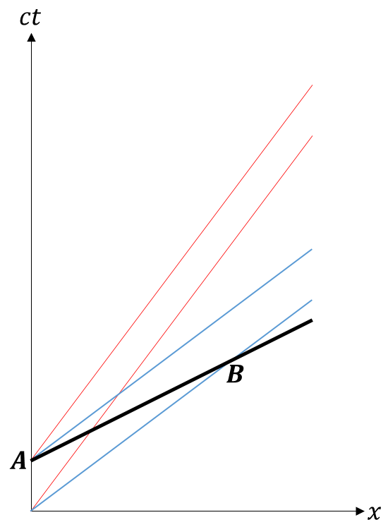In the diagram to the left, the bottom and top blue lines represent the lines where t’=0 and t’=1 respectively for the moving observer, and the red lines do not need to be considered – they are usually an important part of a spacetime diagram, so are shown to make the diagram complete. At the event *A*, The tachyon is emitted from an observed object, at the time *t’*=1, where t’ is the time in the observed object’s reference frame. At a time *t’*=0, however, the tachyon is seen at the event *B*, earlier in the observed object’s timeline than when it was emitted. This is the basis for the main argument against the existence of tachyons – they can violate causality. Using the first principle of relativity,[1] it can be shown that tachyons can appear to travel backwards in time from all frames of reference. This means that tachyons could be used to create what has been named the ‘tachyonic antitelephone’, where a tachyon signal is sent from some point *A* to another, *B*, and in response, *B* sends a tachyon signal back to *A*. In some reference frames it seems that the response signal is sent before the original – a clear sign that they can violate causality.[7]

*The ordering of events A and B change depending on the reference frame*

*The tachyon has moved down the ct’ axis – it has travelled into the moving object’s past*

Because of this problem, and other issues such as tachyons having imaginary mass and speeding up as they lose energy, tachyons are widely believed to be inexistent, although physicists such as Gerald Feinberg have attempted to show that their physics would not be inconsistent with Special Relativity.[8] If they were to exist, they could be used to communicate back into the past, so that the flow of events that happened some time ago could be altered, but because ordinary particles cannot accelerate past *c* to become tachyonic, humanity would not be able to exploit their physics for themselves.

**General Relativity**

It seems, therefore, that Special Relativity does not help us find a method of travelling back in time as much as first hoped. However, it has been shown, in many different ways, that General Relativity may give us reasons to believe that time travel into the past could be possible. The main area of the vast realm of physics that General Relativity is where time travel into the past seems to become a possibility is the formation and use of wormholes – shortcuts from one point in spacetime to another. They are difficult to imagine due to their four-dimensional topology, but can be visualised by considering a spacetime with two spatial dimensions.

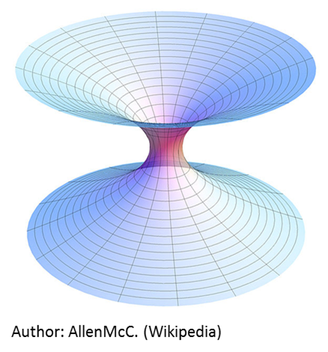Using this spacetime, a wormhole can be explained simply as a tube of spacetime that leads from one area in space to another, as shown to the left – these two areas could be indefinitely far away from one another, immediately opening up the possibility of ‘non-local’ faster than light travel, meaning that *c* is not exceeded by the wormhole traverser at any point, but the travel time would be smaller than that of light travelling between the two points without using the wormhole. In reality, a wormhole would be very similar to the type described above, except the number of spatial dimensions is three instead of two, meaning that two volumes, an indefinite distance apart, would be connected by a four-dimensional ‘tunnel’ through spacetime.

*Wormhole mouths*

*Wormhole throat*

Similarly to tachyons, wormholes have not yet been experimentally or observationally confirmed to exist, but there are valid solutions to the equations of General Relativity which contain wormholes, and there are, in fact, many. The simplest wormholes are known as ‘Schwarzchild’ wormholes, or ‘Einstein-Rosen bridges’.[9][10] They were the first form of wormhole to be theorised, and consist of a black hole, a ‘white hole’, which is a region of space which can’t be entered, but only escaped from (the opposite of a black hole), and two volumes of space which are to be connected. A particle could enter the black hole at one volume in space, and exit out of the white hole at the other volume. Due to the fact that nothing can escape a black hole, and nothing can enter a white hole, Schwarzchild wormholes would not be traversable in both directions. After quasars were first observed, it was believed by a few physicists that they were white holes at the ends of Schwarzchild wormholes.

However, it was shown, by John Wheeler and Robert Fuller, that this type of wormhole was unstable if it connected two volumes within the same universe – the two ends of the wormhole would disconnect too quickly after they had formed for even light to make it from the entrance to the exit, which almost certainly ruled out the possibility of Schwarzchild wormholes existing, let alone being traversable.[11] This was because there was already a problem with the physics of white holes – they seemed to violate the second law of thermodynamics, as they would decrease the entropy of the universe.[22]

Eventually, the possibility of traversable wormholes was demonstrated by Kip Thorne and Mike Morris.[12] The ‘Morris-Thorne’ wormhole would allow particles to travel through it in either direction, unlike the previously theorised Schwarzchild wormhole, but it would need to be held open by a sphere of exotic matter – matter with negative mass. After this first type of traversable wormhole was found, others were discovered, including wormholes which could have naturally formed in the very early universe.[13][14][21]

Since wormholes are a topological feature of spacetime rather than just space, they may be used not only to connect two regions of space, but also two points in time. Because of this, and their ability to allow travel through them in either direction, traversable wormholes seem to allow time travel, forwards or backwards, to be a possibility.[12]

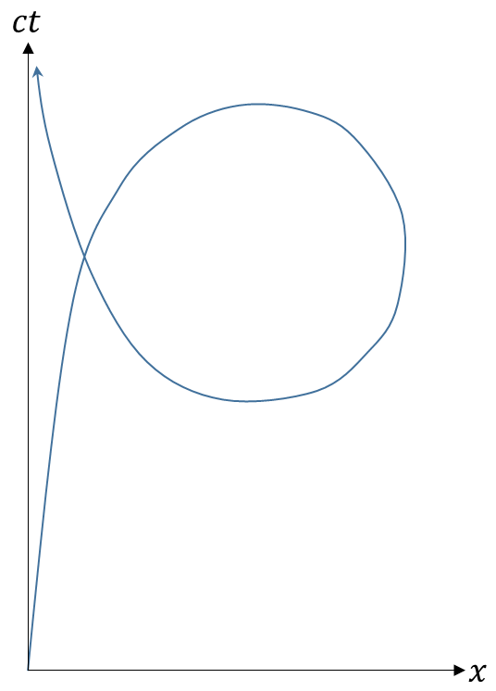Immediately, there are a huge number of problems associated with wormholes which send traversers backwards in time, due to the formation of ‘closed timelike curves’ – paths through spacetime which loop back on themselves. A particle with a trajectory thorough spacetime which formed a closed timelike curve would be able to return to its own past – it would be able to return to a point in spacetime where it had been before, as shown in the diagram. The reason that this is a problem is because the particle could interfere with its own past – for example, it could collide with its former self, causing it to have a different momentum so that its trajectory through spacetime changes, which might prevent the collision from happening in the first place, which would mean a collision would happen, and so on.[25] The closed timelike curve, in this case, has instigated and endless, paradoxical chain with no definite answer to whether the collision happened or not.

*Because of this, it could easily affect the trajectory of its former self – this interaction could prevent the closed timelike curve from forming in the first place, leading to a paradox*

*The particle returns to a point in spacetime where it was previously*

A famous paradox caused by closed timelike curves is the ‘grandfather paradox’, the name given to a paradox that was originally featured in Nat Schachner’s *Ancestral Voices*.[23] In the paradox, a traveller traverses a wormhole to travel back in time to a time before their grandparents met, and kills their grandfather. This, therefore, causes their grandparents not to meet, and the traveller is never born. If they were never born, they couldn’t have killed their grandfather, which would mean he would be born, and so on. Variants to the paradox have been used many times in science fiction, including the plots of *Doctor Who*, *Back to the Future* and *Star Trek*.

*The traveller enters the wormhole in 2015*

*The traveller is not born, so never went through the wormhole, thus never killed his grandfather, so he was born, etc.*

*The traveller exits in 1960*

*The traveller kills his own grandfather*

Some physicists have argued that backwards time travel, without paradoxes, could be possible if the time lines created were fully self-consistent.[26] In other words, the actions of the traveller once he has travelled back in time must have been part of history all along, so that the traveller is unable to prevent himself from going back in time. This idea was used in the film *Primer*, in which the main characters check and remember stock prices, travel back in time and make money using their knowledge of the performance of the stock market.[24] An expansion of this ‘Novikov self-consistency principle’ was proposed, in which the probabilities of events occurring continually change in order to prevent paradoxes from occurring. This could lead to incredibly bizarre situations if the traveller gets close to causing a paradox.[27][28]

It is thought that wormholes, such as the ones described above, which violate causality – those which allow light to pass through it and back to the starting point at a time earlier than it was originally sent – could not be used as a time machine in reality, as analysing the traversing of particles through such wormholes has shown that the wormhole would collapse very quickly after a particle attempted to traverse it,[15] thus agreeing with Stephen Hawking’s ‘chronology protection’ conjecture, which states that the laws of physics prevent time travel on all but the smallest of scales of the universe.[16]

However, a certain configuration of wormholes, each of which on their own do not violate causality, could all be traversed in order so that causality could be violated, due to Hawking’s conjecture not being able to prevent these wormholes from collapsing.[17]

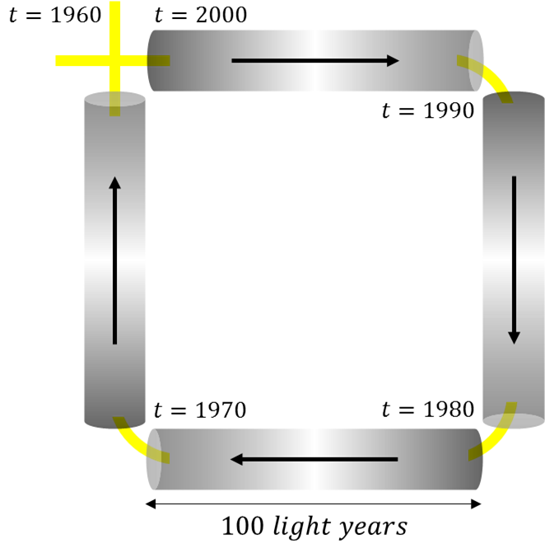For example, consider four wormholes which each send a traversing particle from one entrance to another point in spacetime one hundred light years away and ten years into the past. Since light that passes through one of the wormholes would take one hundred years to return to where it originally entered it, each wormhole separately does not violate causality. Suppose that each of the wormholes’ entrances and exits are right next to another wormhole’s exit or entrance, so that a particle could pass through each of the four wormholes in succession. A particle could enter the first wormhole in the year 2000 and exit in the year 1990, then travel through the next one, then the third, and finally the last so that it returns to its starting point space, but forty years earlier than the time it entered the first wormhole, in the year 1960, thus travelling forty years backwards in time.

*Each of the individual wormholes don’t violate causality, but the system of four of them does – the particle uses each of the wormholes to travel ten years into the past, therefore ends up forty years earlier in time, in the same location as it started*

It is thought that these sets of wormholes, known as ‘Roman rings’, may be shown not to be possible by a full theory of quantum gravity, as the semiclassical approach (using an approximation of quantum gravity) to analysing traversable wormholes may be unreliable when considering these configurations.[17] Because of this, it is currently impossible to determine whether wormholes, if they exist or could be created, could be used to travel backwards in time, but the fact that General Relativity and estimations of quantum gravity seem to disagree with each other to an extent shows that the fact that wormholes can appear in solutions to the equations of General Relativity is most certainly not enough to be sure that they could exist in reality.

One possible resolution to the problems that appear when studying wormholes using the semiclassical approach is to use the ‘many-worlds’ interpretation of quantum mechanics, which implies that all of the possible histories and futures of the universe are real, so that there are an extremely large or possibly infinite number of universes.[18] The basic idea is that everything that could have happened in our universe’s past, but didn’t, has happened in the past of some other universe or universes.

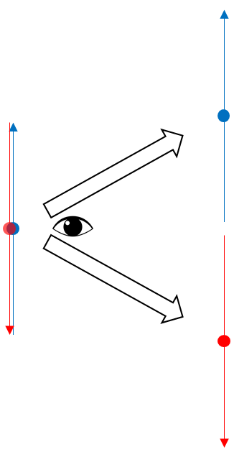A simple situation where there could be two different possible universes is the measurement of the spin of a single electron. For example, a stationary electron is prepared so that its spin is up along the *x* axis – this could be achieved by turning on a uniform magnetic field along the *x* axis to make the electron’s spin point up along that axis, because that will allow it to be in its lowest energy state. After turning off the magnetic field, the electron definitely has its spin pointing up along the *x* axis. However, when a magnetic field is turned on along the *y* axis, there is a 50% probability that the electron’s spin was up along that axis, and a 50% probability that it was down along that axis. The ‘many-worlds’ interpretation of quantum mechanics argues that two universes split off from one another at the point in time that the electron’s spin is observed, one in which the electron’s spin was up and one where it was down. This probabilistic nature of the observed spin of microscopic particles was first experimentally discovered by Otto Stern and Walther Gerlach in 1922.[19]

*The electron is in a superposition of states – its spin is pointing both up and down, but until its spin is observed, it is not definitely one or the other*

*The electron’s spin is observed, and, according to the ‘many-worlds’ interpretation, both possible universes, each containing the different results of the observation, are real*

The ‘many-worlds’ interpretation effectively states that there is a ‘multiverse’ – a collection of many universes. The reason that this a useful idea when considering ways to resolve the paradoxes associated with wormholes, is because if there is a multiverse, then a wormhole could be a path from one universe to an almost identical one, except any paradoxes that could happen, if the wormhole connected two parts of the same universe, would not due to the slightly different states of the two connected universes.

A problem with the idea that there is a correlation between the multiverse described by the ‘many-worlds’ theory and the multiverse required for the paradoxes associated with wormholes to be resolved is that the type of multiverse required for each seems to be different. In 2003, Max Tegmark wrote a paper in which he described a hierarchy of multiverses, with the possible diversity increasing with each level.[20] In his hierarchy, a level 3 multiverse is required for the ‘many-worlds’ theory, while a level 1 ‘multiverse’ is needed to satisfy the idea that that wormholes don’t violate causality. In the case of the level 1 ‘multiverse’, there is, in fact, only one large universe, perhaps infinitely big, but the wormhole connects two very distant parts of the universe which seem to be almost identical. Tegmark conservatively estimates that if the level 1 ‘multiverse’ exists, then roughly metres away, there should be at least one perfect copy of any person, and metres away there should be at least one sphere of space with a radius of 100 light years which is totally identical to the sphere of space with the same volume centred at the Earth.

*The traveller enters the wormhole in one region of space…*

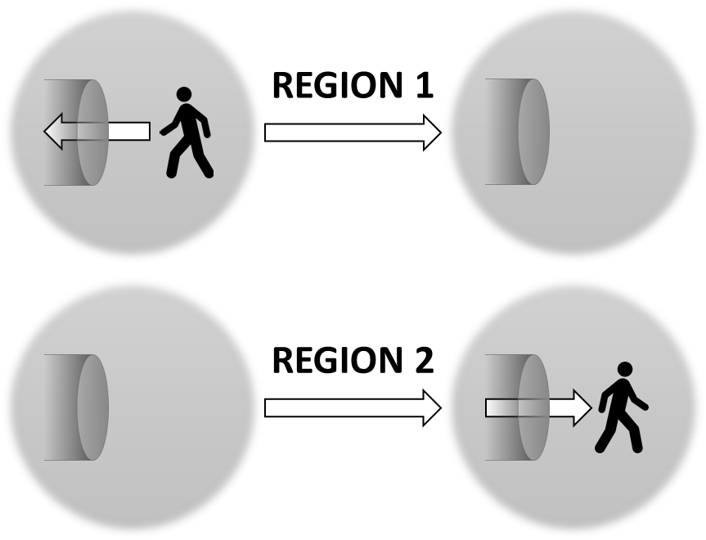Continuing this trail of thought it is not difficult to imagine that if one was to look at a region of the universe large enough there could be an exact replica of our observable universe, a region of space in which some traveller appears to have traversed a wormhole from another region of space which seems identical to the one he has entered, or even a region of space identical to our observable universe as it was 100 years ago. The difference between the level 1 and level 3 multiverses is that the former describes hugely distant regions of the same universe which legitimately could be completely unconnected, yet seem identical to a certain extent, while the latter version states that if one looked back into the past of two seemingly unrelated universes, it will be found that they had the same past before some point. Since the types of multiverse described by level 1 and level 3 of Tegmark’s hierarchy are independent of one another, it is possible that both forms of multiverse could exist.

*…and exits in another large region of space, in the same universe, which looks like how the first region was 100 years ago*

Therefore, if the level 1 ‘multiverse’ exists, then wormholes, if they exist, could lead from one observable universe to another which appears identical to the former as it was 100 years ago, or as it will be 100 years into the future, but is totally unrelated. Since these wormholes would not actually send a traverser backwards or forwards in time, they do not violate causality, thus they would be allowed by the chronology protection conjecture, and ‘Roman rings’ would not form, agreeing with the suggestion that they would be prevented by the physics of a full theory of quantum gravity. However, it would be very easy for the traveller to believe he had time travelled.

Wormholes of this type, therefore, could appear to send traversing particles forwards or backwards in time, but in reality, would actually only be sending them extremely far away to some distant part of the universe. This means that basic Schwarzchild wormholes could not be traversed, because they would collapse as explained above, which is an issue, as all traversable wormholes described using unmodified General Relativity require exotic matter, which so far has not been observed.

There does seem to be, after all, types of wormholes which might exist without causing paradoxes, violating the chronology protection conjecture or violating the laws of physics as they are currently understood, which, as will be explained below, could prove to be useful in the future.

**The Reality of Time Travel**

Moving away from the realm of the many theories related to time travel, wormholes and parallel universes, humanity may want to travel huge distances in the future. Reasons that humans may want to do this include travelling to other stars or galaxies to gather information, or even travelling far from Earth to set up a colony on another habitable planet. If this happens, humans on Earth may want to send signals to and receive signals from those far away in the universe, but sending information through space would mean that the signals could take huge amounts of time to get from the sender to the receiver. Therefore, a wormhole could be used so that the signals would take far less time to reach the recipients.

The problem is, the humans, who would originally have to have travelled extremely far away, would probably not be able to use wormholes, as the gravitational forces exerted close to them are thought to be similar to those of a black hole – this would mean that travelling through a wormhole could almost certainly be deadly.[29] Therefore, humans, if not brave enough to try a wormhole, would need to use another method to travel these great distances within their lifetime.

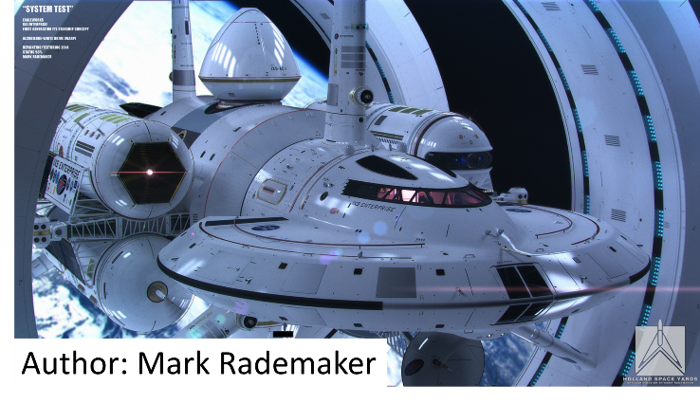Recently, NASA announced that it had started work on building a warp drive to allow for ‘apparent’ faster-than-light travel.[30] This spaceship, the concept art for which is to the left, if built, will rely on drastically distorting spacetime so that it can travel to a star in less time than it would usually take for the light from that star to reach Earth.[31] The spaceship itself would not travel faster than light could with respect to the region of distorted spacetime. For example, Harold White, who announced the project was underway, surmised that the spaceship would be able to reach Alpha Centauri, 4.3 light years away, in two weeks.[32]

If a ship such as this, with warp drive technology, is built, and a suitable fuel to power it is found, it would certainly be an effective way of travelling to distant stars and possibly other galaxies. However, due to the laws of Special Relativity, it is possible to travel huge distances in small amounts of time without warping spacetime, as long as the spaceship accelerates quickly enough, travels fast enough, and has a *lot* of fuel available to use.

While Special Relativity is thought by many to be unable to deal with any form of acceleration, it is possible to formulate a set of relativistic equations of motion for moving bodies with constant acceleration, analogous to the ‘*SUVAT*’ equations of non-relativistic kinematics.

In non-relativistic kinematics, a particle moving with uniform acceleration in some frame of reference R means that the acceleration, ***a***, of the particle measured in that frame is constant. The equation for the velocity, ***v***, of the particle at the time *t*, is:

where ***u*** is the initial velocity of the particle.

Integrating once more gives the equation for the position, ***x***, of the particle at the time *t*:

where ***x0*** is the initial position of the particle.

If ***x0*** and **u** are both taken to be 0, five simplified versions of the ‘*SUVAT*’ equations can be derived:

where ***x*** has been replaced by ***s***.

It is possible to construct a relativistic set of the equations above, so that a particle’s acceleration doesn’t cause its speed to become greater than *c*.

Starting with the Lorentz transformations of position and time:

where *γ* is the Lorentz factor:

One can form the equations

and use them to find the equation for the relativistic transformation of velocity:

One can find the derivative of ***u’*** with respect to *t’*, finding the transformation of acceleration to be:

As these equations consider only one spatial dimension, one can allow |***v***|2 to be equal to ***v***2. If one allows ***u*** to be equal to ***v***, one can find the proper acceleration, ***α***, or the experienced acceleration of a particle observed to have acceleration ***a*** and velocity ***v***:

Rearranging and integrating, one finds

Rearranging once more, one finds the velocity, ***v***, at the time *t*:

This is the first of the relativistic ‘*SUVAT*’ equations. Taking ***u***, or the initial velocity, to be 0, the constant of integration is removed.

Integrating again gives us the position, ***s***, at the time *t*:

Since ***x0***, or the initial position, is assumed to be equal to 0, the constant of integration is equal to -*c*2*/****α*** so that the position of the particle at time *t*=0 is equal to 0. A more useful form of the equation can be found by rearranging the equation to make *t* the subject:

One can now also find the proper time, τ, or the time elapsed in the accelerating frame of reference. Making use of another equation involving the Lorentz factor

one can rewrite the equation relating ***α*** and ***a***:

Integrating this equation and then rearranging the result yields

where the constant of integration is again ignored so that *τ*=0 when ***v***=0.

The set of equations derived above can now be used to find the time dilation that occurs, or the difference between the coordinate time, *t*, and the proper time, *τ*, when a journey of some distance, ***s***, is made with constant acceleration in the accelerating frame, ***α***. The observed acceleration, ***a***, can be found after finding the final velocity, ***v***, and using the equation relating ***a*** and ***α***.

For example, if humanity found a habitable planet in the Andromeda galaxy, 2.4 * 1022 meters away, and wanted to travel to that planet to form a new civilisation, they would have to start their journey at rest relative to the Earth. If the constant acceleration in the accelerating spaceship’s frame, ***α***, was equal to *g*, the acceleration due to Earth’s gravity, it would appear to take 8 * 1013 seconds, or just over two and a half million years, to complete the journey to an observer on Earth, while the time experienced by the travellers would only be only 4.7 * 108 seconds, or fifteen years, due to the large amount of length contraction of the space between the spaceship and the distant galaxy. The final acceleration observed back on Earth would be only 5.4 * 10-19 metres per second per second, as the final velocity of the traveller would be very close to *c* – just 20 micrometres per second slower than *c*.

One problem with this form of interstellar travel, just like the warp drive method, is that a huge amount of fuel would be needed to make these huge journeys. The energy required to make the journey can be found using the relativistic equation for kinetic energy:

Assuming the mass of the spaceship, *m*, is equal to that of a space shuttle, or 2 million kilograms, the energy required for the spaceship to reach its final velocity would be 5 * 1029 joules, equivalent to roughly 2 trillion times the amount of energy released by the worldwide burning of coal in 2012.[33][34] Even if the spaceship was fuelled by the annihilation of matter and antimatter, where all of the mass of the annihilating particles would be turned into energy,[35] 5 * 1012 kilograms of antimatter would be required – a much larger mass than that of the spaceship. This is only an estimate, as the amount of fuel actually required for the trip could vary due to the ship needing to decelerate to rest relative to the target planet.

One hope is that there is a habitable planet within the Milky Way, which would drastically shorten the travel time, and, more importantly, the amount of fuel required would be much lower, making antimatter fuel a possibility.

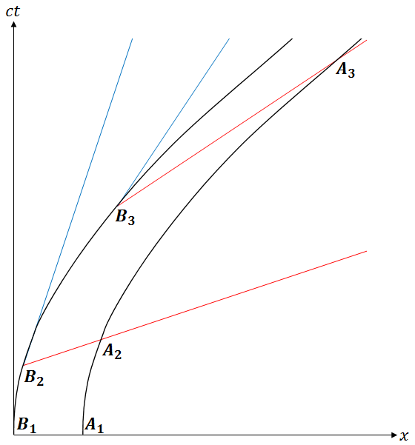The reason that the acceleration of the spaceship is important to consider is because of the simple fact that it has a length – plotting a spacetime diagram of the journey towards the Andromeda galaxy shows that the time coordinate of the front of the ship moves ahead of the time coordinate of the back of the ship. To the left, *A* is the front of the ship and *B* is the back. The red lines represent *x’*=0 – they are the lines on which events happen at the same time for the ship, while the blue lines represent *t’*=0, which doesn’t need to be considered. As the ship accelerates, the *x’* axis becomes a steeper and steeper line due to the Lorentz transformation from the observer’s frame to the ship’s frame, causing the difference between the speeds of the front and the back of the ship to increase.[36] Because of this, a ‘relativistic stress’ will be induced, and if the spaceship accelerates too much, then after some velocity it will be ripped apart.[37] Therefore, the spaceship would need to be made of a material as sturdy as possible, so that the largest velocity can be reached before it has to stop accelerating. This means that the travellers would have to be very careful and make sure to stop accelerating after the correct amount of time, and the acceleration would have to be as rapid as possible so that the stretching force on the rocket would last for as little time as possible.

*Ever-changing line of the present for the back of the ship*

*As the velocity of the spaceship increases, the velocity of the front of the ship relative to the back, as seen at the back of the ship, increases, which leads to the rocket being stretched and pulled apart*

**Conclusion**

Overall, it has been shown that time travel takes many forms, and some types are certainly possible, while others can’t currently be tested and are highly theoretical. The use of long distance travel and acceleration to travel arbitrarily far into the future has been proven by experiment and is possibly the simplest method of time travel – it doesn’t, however, allow for the time traveller to meet their future self. The tachyon seems to be a particle which does not fit in with are current understanding of the types of particle that exist – all particles discovered so far have non-imaginary mass, and none of them travel faster than *c*. Although this is the case, and their physics is extremely different to any other particle, the equations of Special Relativity do not prevent them from existing, as they technically do not break the speed of light barrier – they always travel faster than *c*. Wormholes, again, are currently highly theoretical geometric structures in spacetime, but they are not prevented by General Relativity. Because of this, their ability to form closed timelike curves and allow time travel into the future and even the past must be investigated seriously. There have been attempts to prevent the formation of wormholes, and other theories which have presented solutions to the apparent paradoxes that would occur if they were used, but so far there has been no proof of them existing or not. If they did exist, there is still the question of where they would send a traveller in spacetime – whether they would they really send them back into the past of the same universe, into another region of the universe which is totally physically unrelated to the previous region, or into another universe altogether is not yet clear, but from examining the ideas presented by physicists about the physics of wormholes it seems that the most plausible solution to the problem is that wormholes connect two distant regions of the universe, which would both solve the paradox of closed timelike curves and allow for movement through both space and time. Finally, if humanity wanted to fully make use of the form of time travel which is currently known to be possible to travel to a nearby star, extreme acceleration to a speed very close to *c* could be used so that the travel time would be very short for the travellers. However, problems include the relativistic stresses on the spaceship during the acceleration, the huge amount of energy required and the fact that the travellers would return to Earth far into the future, unable to return to the world they once knew.

While the time travel described by Special Relativity is certainly possible, the strange physics of wormholes, closed timelike curves and the so far elusive theory quantum gravity is far more interesting, and the ability to freely travel backwards or forwards in time, or to a super distant observable universe almost identical to our own, is one which would open up many possibilities for humanity, if brave and adventurous enough to use it.

There has already been physics discovered where logic has been conquered by experiment and theory – hopefully the same is the case here.

**Word count: 6218**

**References**

1. Einstein, A. (1905). Zur Elektrodynamik bewegter Körper. *Ann. Phys.*, 322(10), pp.891-921.
2. Behroozi, F. (2014). A Simple Derivation of Time Dilation and Length Contraction in Special Relativity. *The Physics Teacher*, 52(7), pp.410-412.
3. Hafele, J. and Keating, R. (1972). Around-the-World Atomic Clocks: Observed Relativistic Time Gains. *Science*, 177(4044), pp.168-170.
4. Dunsby, P. (1996). *Spacetime diagrams and the Lorentz transformations*. [online] Mth.uct.ac.za. Available at: http://www.mth.uct.ac.za/omei/gr/chap1/node4.html.
5. Feinberg, G. (1967). Possibility of Faster-Than-Light Particles. *Physical Review*, 159(5), pp.1089-1105.
6. Norton, J. (2012). *Spacetime, Tachyons, Twins and Clocks* [online] Pitt.edu. Available at: [http://www.pitt.edu/~jdnorton/teaching/HPS_0410/chapters/spacetime_tachyon](http://www.pitt.edu/~jdnorton/teaching/HPS_0410/chapters/spacetime_tachyon/).
7. Tolman, R. (1917). *The theory of the relativity of motion*. Berkeley: University of California Press, pp.54-55.
8. Feinberg, G. (1970). Particles that go Faster than Light. *Sci Am*, 222(2), pp.68-77.
9. Flamm, L. (1916). *Excerpts Flamm, L.: "Beiträge* *zur Einsteinschen Gravitationstheorie," 1916*. [online] Available at: <http://digital.library.pitt.edu/u/ulsmanuscripts/pdf/31735061848028.pdf>.
10. Einstein, A. and Rosen, N. (1935). The Particle Problem in the General Theory of Relativity. *Physical Review*, 48(1), pp.73-77.
11. Fuller, R. and Wheeler, J. (1962). Causality and Multiply Connected Space-Time. *Physical Review*, 128(2), pp.919-929.
12. Morris, M., Thorne, K. and Yurtsever, U. (1988). Wormholes, Time Machines, and the Weak Energy Condition. *Phys. Rev. Lett.*, 61(13), pp.1446-1449.
13. Gravanis, E. and Willison, S. (2007). Mass without mass’ from thin shells in Gauss-Bonnet gravity. *Physical Review D*, 75(8).
14. Cramer, J., Forward, R., Morris, M., Visser, M., Benford, G. and Landis, G. (1995). Natural wormholes as gravitational lenses. *Physical Review D*, 51(6), pp.3117-3120.
15. Visser, M. (1994). Hawking's chronology protection conjecture: singularity structure of the quantum stress-energy tensor. *Nuclear Physics B*, 416(3), pp.895-906.
16. Hawking, S. (1992). Chronology protection conjecture. *Physical Review D*, 46(2), pp.603-611.
17. Visser, M. (1997). Traversable wormholes: The Roman ring. *Physical Review D*, 55(8), pp.5212-5214.
18. Everett, H. (1957). "Relative State" Formulation of Quantum Mechanics. *Reviews of Modern Physics*, 29(3), pp.454-462.
19. Gerlach, W. and Stern, O. (1922). Das magnetische Moment des Silberatoms. *Z. Physik*, 9(1), pp.353-355.
20. Tegmark, M. (2003). Parallel Universes. *Sci Am*, 288(5), pp.40-51.
21. Visser, M. (1989). Traversable wormholes: Some simple examples. *Physical Review D*, 39(10), pp.3182-3184.
22. Wald, R. (2001). The Thermodynamics of Black Holes. *Living Rev. Relativity*, 4.
23. Schachner, N. (1933). *Ancestral Voices*. 1st ed. [ebook] Street & Smith Publications. Available at: <http://www.fadedpage.com/books/20130818/20130818.html>.
24. Woerner, M. (2011). *The Definitive Graph of All of Primer's Intersecting Timelines*. [online] io9. Available at: <http://io9.com/5847205/the-definitive-graph-of-all-of-primers-intersecting-timelines>.
25. Thorne, K. (1994). *Black holes and time warps*. New York: W.W. Norton, pp.510-511.
26. Friedman, J., Morris, M., Novikov, I., Echeverria, F., Klinkhammer, G., Thorne, K. and Yurtsever, U. (1990). Cauchy problem in spacetimes with closed timelike curves. *Physical Review D*, 42(6), pp.1915-1930.
27. Deutsch, D. (1991). Quantum mechanics near closed timelike lines. *Physical Review D*, 44(10), pp.3197-3217.
28. Lloyd, S., Maccone, L., Garcia-Patron, R., Giovannetti, V. and Shikano, Y. (2011). Quantum mechanics of time travel through post-selected teleportation. *Physical Review D*, 84(2).
29. Nandi, K., Zhang, Y. and Zakharov, A. (2006). Gravitational lensing by wormholes. *Physical Review D*, 74(2).
30. McCormick, R. (2014). *We could travel to new worlds in NASA's starship Enterprise*. [online] The Verge. Available at: <http://www.theverge.com/2014/6/13/5806104/nasas-warp-drive-spaceship-concept-enterprise>.
31. González-Díaz, P. (2000). Warp drive space-time. *Physical Review D*, 62(4).
32. Dvorsky, G. (2012). *How NASA might build its very first warp drive*. [online] io9. Available at: <http://io9.com/5963263/how-nasa-will-build-its-very-first-warp-drive>.
33. Eia.gov, (2015). *International Energy Statistics - EIA*. [online] Available at: <http://www.eia.gov/cfapps/ipdbproject/IEDIndex3.cfm?tid=1&pid=7&aid=1>.
34. Energy in natural processes and human consumption - some numbers. (2005). [online] Available at: <http://www.ocean.washington.edu/courses/envir215/energynumbers.pdf>.
35. Mastin, L. (2009). *Antimatter - The Big Bang and the Big Crunch - The Physics of the Universe*. [online] Available at: <http://www.physicsoftheuniverse.com/topics_bigbang_antimatter.html>.
36. Petkov, V. (2009). *Accelerating spaceships paradox and physical meaning of length contraction*. [online] Arxiv.org. Available at: <http://arxiv.org/abs/0903.5128>.
37. Franklin, J. (2009). *Lorentz contraction, Bell's spaceships, and rigid body motion in special relativity*. [online] Arxiv.org. Available at: <http://arxiv.org/abs/0906.1919>.

**Glossary**

**Annihilation** – The process that occurs when a particle meets with its corresponding antiparticle. They annihilate and all of their mass is turned into energy, in accord with the equation *E=mc*2.

**Antimatter** – Material composed of antiparticles – it has the same mass but opposite charge, spin and other properties of matter.

**Causality** – The link between one event and another, where one of the events is the cause for the other.

**Entropy** – The disorder, or randomness, of a physical system.

**Imaginary Value** – A mathematical value for which a negative number is formed when squared.

**Kinematics** – An area of mathematics concerned with the motion of objects, and not the forces which cause it.

**Length Contraction** – The decrease in length of an object measured by an observer or physical system which occurs when it is moving relative to the observer.

**Light Year** – The distance light travels in a vacuum in one year.

**Lorentz Transformations** – A correction of the classical transformations of position and time which is in agreement with Special Relativity.

**Observable Universe** – The volume of space in which objects can be observed due to light having had time to travel from them to Earth since the beginning of the expansion of the universe.

**Quantum Gravity** – The area of theoretical physics which seeks to describe the force of gravity according to the principles of quantum mechanics and quantum field theory, and to unify gravity with the other fundamental forces.

**Quasar** – An extremely bright celestial object which is emitted from a very energetic active galactic nucleus.

**Reference Frame** – A set of coordinates related to an observer’s state of motion.

**Relativistic** – Physics of this type can only described by Einsteinian relativity, usually when the speeds involved are close to *c*.

**Second Law of Thermodynamics** – States that entropy of a physical system must increase over time.

**Spacetime** – A single continuum formed by the combination of space and time.

**Spin** – A quantum mechanical property of microscopic particles which is quantised – it can only take one of a discrete set of values – for a spin ½ particle, such as an electron, the only possible spins are up and down.

**Tachyonic** – A tachyonic object is an object which appears to be travelling faster than *c*.

**Transformation** – An equation which converts the value of a coordinate from one coordinate system, or reference frame, to another.